Kartik AI Fit

You are a senior AI product architect and full-stack developer. Your task is to carefully read, understand, and execute all planning, design, and implementation work based strictly on the complete product document provided below.

Mobile App Main Functions and Work Name with single Motive is Motivate people for Healthy Life
1. Workout Planner And Tracker And Analyser
In this Function My App Check First user Time table user Time Period For under Standing For Create best Workout time Space For User using Ai
Our App Create A Workout Routine and Workout Positions ( like Push Ups Squat and Many More etc According user Condition Like other famous Apps ). Analyzing Using Camera And User Confirmation OF Activity. And Its Use Camera For Check User right Posture of Workout Activity. And Also Time Watch System By App Fix Time depend plan of workout Activity
2. Dieght Planner And Calories Checker Planner
My apps Check user Food On Routine Also Create Diet Plan and Easy to Manage Health And Also Analyss Calories Feed/ Take By User With Help Of Using Ai Api Because Its Basic Details Of Calories
3. Period Tracker For Only female
Check Timing Of Period And Cycle period Of Period Also Base On these Create Workout Diet Plan For Female
4. Connect With Google Fit And Also Maximum Watch Brand Connectivity
Analyize with Heart Beat using Google Fit Smart watches and many more
5. Master Analysis And Report Tracker And Extractor with Pdf
Major Feature :- A Ai Character Like Indian Brother/Sister Voice Vibe to Assist User With Friendly Language for Feel real Person and Friend

I want My app work Like this

🎯 0️⃣ Install → Activation Funnel
Flow:
- User installs app
- Opens → Splash
- Language select
- Goal select
- Profile setup
- Dashboard loads
Backend Connections:
- Create user_id
- Save goals
- calculate daily calorie target
- create streak base
- schedule reminder engine
Now system is ready.

🧭 1️⃣ Dashboard = Central Nervous System
This screen connects all modules.
Shows:
- calorie ring
- add food button
- workout card
- steps mini card
- ARIA insight
- streak
Backend Pull:
Dashboard API fetches:
- today_food_total
- today_workout_status
- step_count
- water_log
- streak_days
- AI_tip
This is aggregated response endpoint.

🍛 2️⃣ Food Logging Workflow (Growth Loop)
User Flow:
- Click Add Food
- Camera open
- Take photo
- Suggestion list
- Portion select
- Confirm
Backend Logic:
- Photo stored (dataset building)
- Suggestion engine runs (text + embeddings)
- User selects food_id
- Portion multiplier applied
- Calories added to daily log
Connections:
- updates dashboard
- updates nutrition history
- feeds AI coach

🏋️ 3️⃣ Workout Planner Workflow (Retention Engine)
User Flow:
- Dashboard → Start workout
- Stopwatch screen
- Exercise sequence
- Rest timer auto
- Finish → calories burned
Backend:
- session_start event
- session_progress updates
- session_complete save
Connections:
- progress graph
- streak logic
- AI weekly summary

👣 4️⃣ Activity Tracking Workflow
Sources:
- phone sensors
- Health Connect
- manual input
Data Saved:
- steps
- distance
- active minutes
Dashboard Impact:
- step card update
- calorie burn estimate
- habit completion %

🤖 5️⃣ ARIA AI Coach Workflow (Personalization Brain)
Inputs:
- food logs
- workout history
- missed days
- goal type
- schedule
Outputs:
- daily tip
- motivational push
- meal suggestion
- next workout suggestion
Example Logic:
IF calorie deficit high → suggest snack
IF workout skipped → suggest short plan
AI runs as insight layer, not core logging engine.

📊 6️⃣ Progress Engine (Subscription Driver)
Weekly calculations:
- avg calories
- workout consistency
- weight trend
- streak trend
Generates:
- transformation card
- unlock premium insights
Monetization Trigger:
After:
- 5 day streak
- visible graph
- AI personalized insight
Show Pro upgrade.

🔔 7️⃣ Notification System (Habit Builder)
Triggers:
- morning reminder
- meal missed
- workout pending
- streak risk
Engine logic:
- time zone
- user schedule
- past response behavior

🧠 8️⃣ Data Flow Architecture (Simple View)
Mobile App
↓
API Gateway
↓
Core Services:
- Food Service
- Workout Service
- Activity Service
- AI Insight Service
- Notification Service
↓
Database:
- user
- food_logs
- workout_sessions
- activity_metrics
- streaks

⚡ Daily User Loop (Most Important)
Morning → check dashboard
Afternoon → log lunch
Evening → workout
Night → see progress
Repeat daily.
This creates:
- habit
- retention
- data moat
- subscription readiness

⭐ One-Line System Summary
Dashboard collects → Modules update → AI interprets → Notifications push → User returns.
That is the full product loop.

Ui Example For App
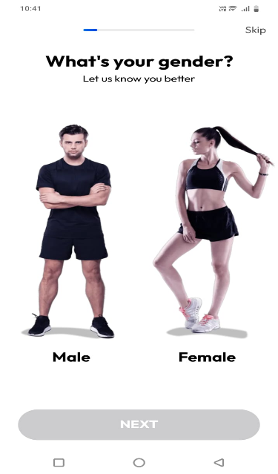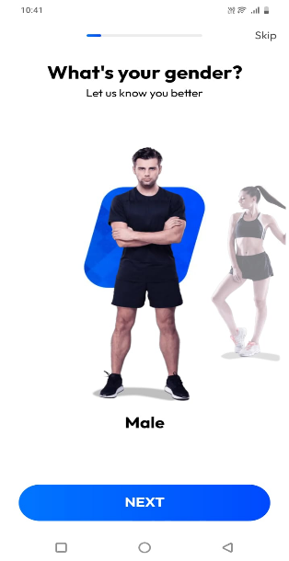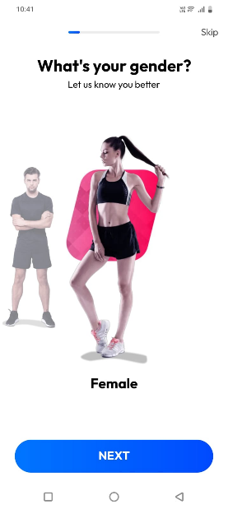

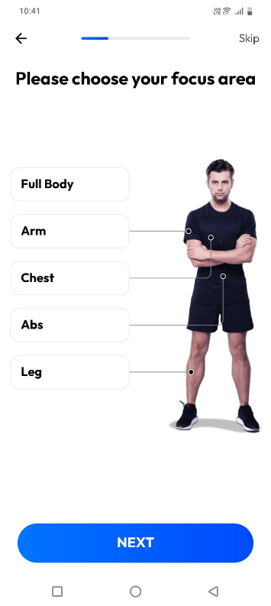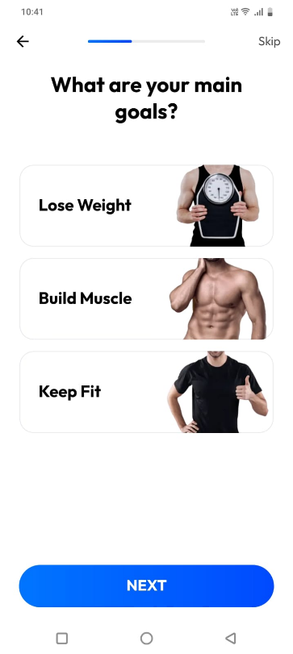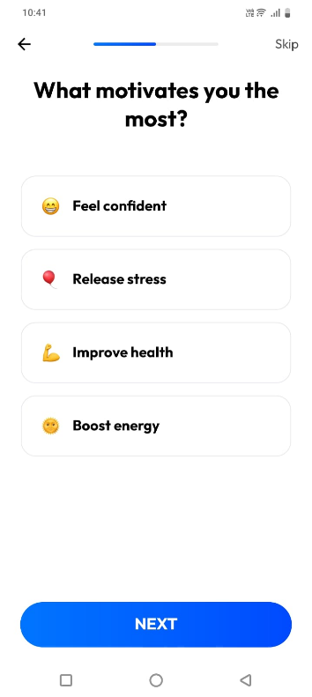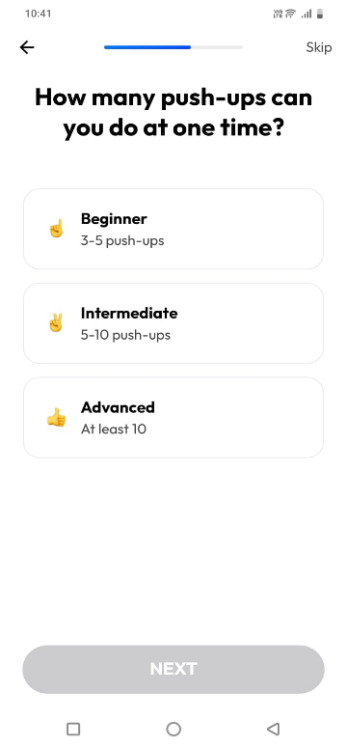
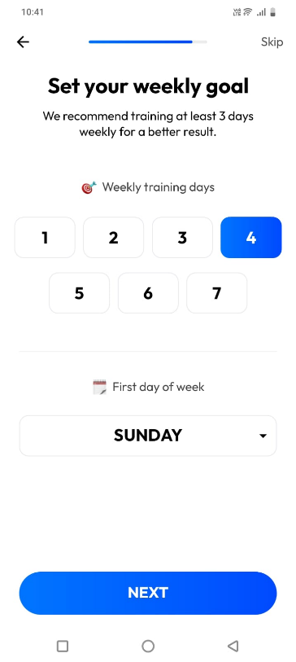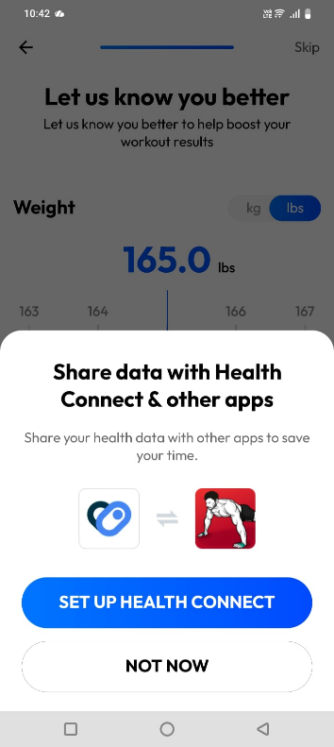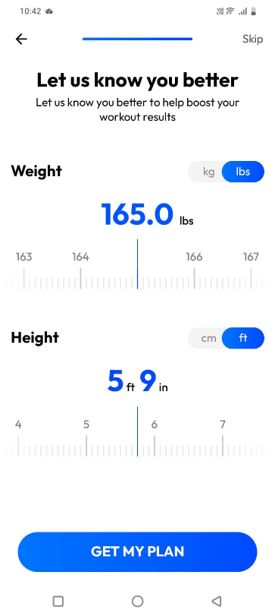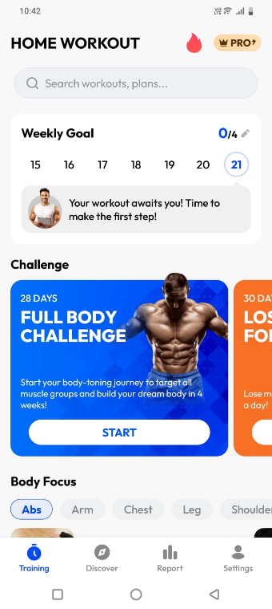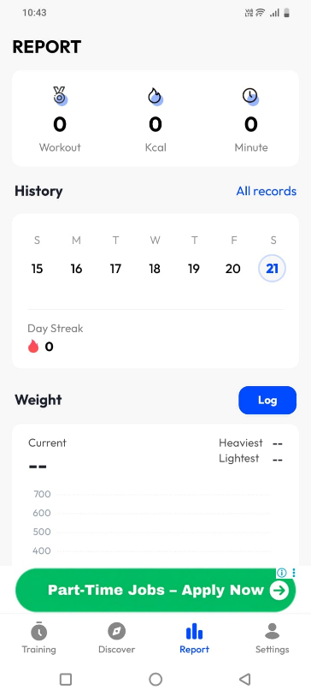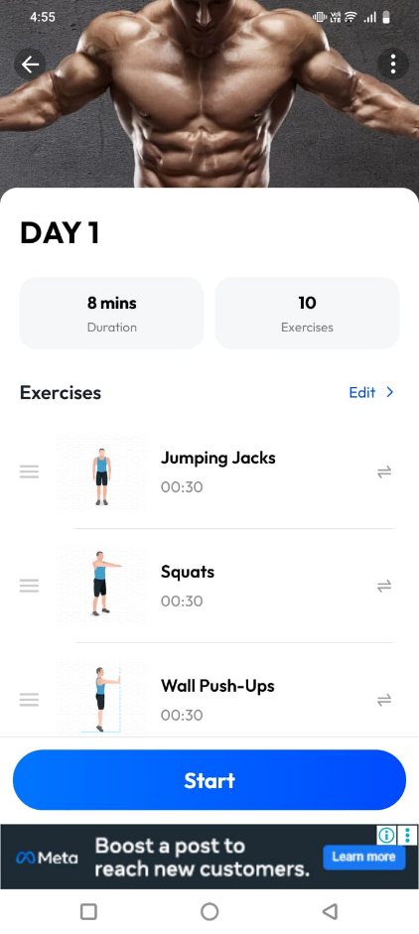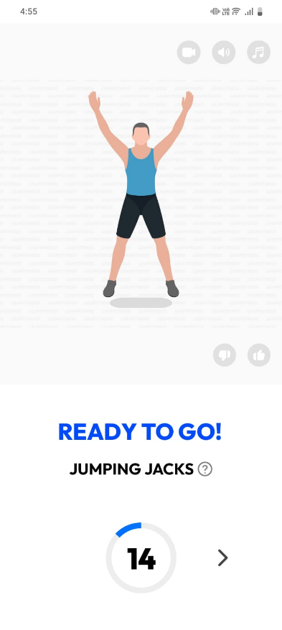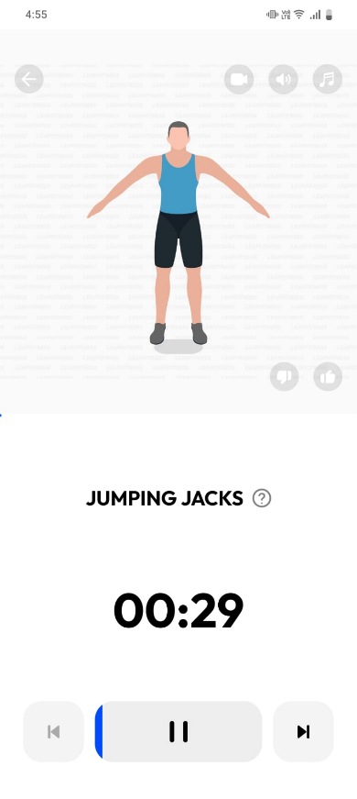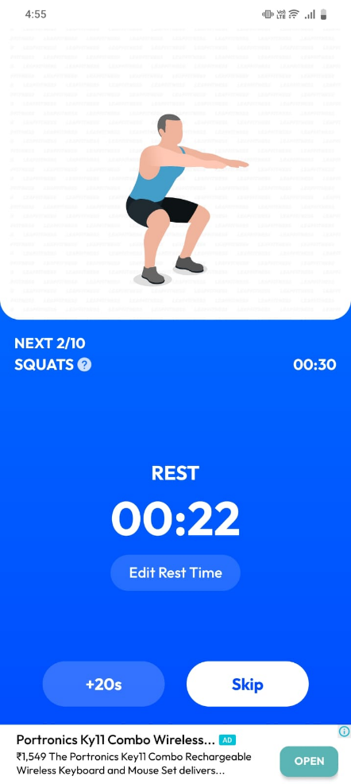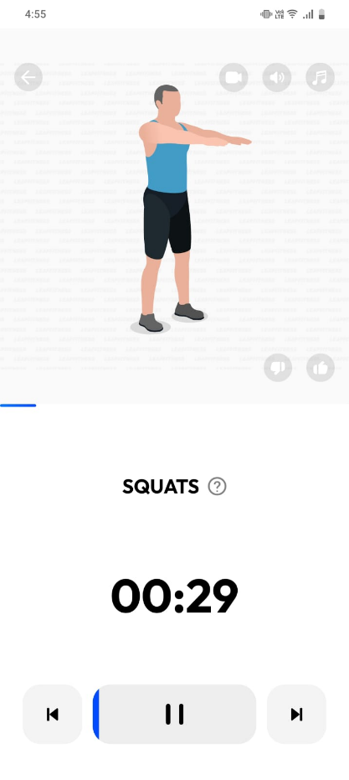

✅ Core Navigation Tabs → 5 Main Pages
These are bottom navigation tabs.
1️⃣ Home (Dashboard)
Purpose:
- daily summary
- calorie ring
- workout card
- steps card
- AI tip
- streak
This is most visited screen (60% usage).

2️⃣ Food History / Nutrition Page
Purpose:
- meal timeline
- macros summary
- edit / delete food
- add water

3️⃣ Workout Page
Purpose:
- today workout
- plan list
- start workout
- exercise library

4️⃣ Progress Page
Purpose:
- weight graph
- calorie trend
- workout consistency
- streak history

5️⃣ AI Coach Page
Purpose:
- chat UI
- quick suggestions
- weekly summary

Profile Setup
Settings
Notifications Center

